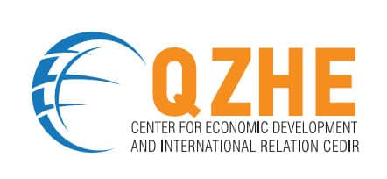  1st Open Tourism Board 5th May 2021  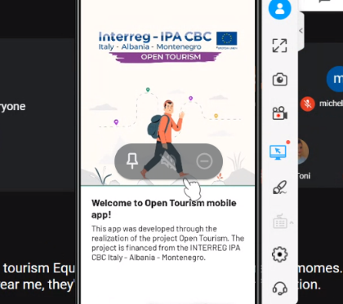 | On 5th May 2021 was organized the first meeting of the Open Tourism Board, with the presence of:  - Mr. ALFREDO LONGO (President of the Union of Municipalities Lands of the Sea and the Sun)  - Mr.CARLETTO DI PAOLA (President of the Union of Municipalities Sorgenti del Biferno)  - Mr. REMÌ CALASSO (President of the Porto Cesareo Marine Protected Area)  - Mr. ARMANDO SUBASHI (Mayor of the Municipality of Fier)  - Mr.ALEKSANDAR KAŠĆELAN (Mayor of the Municipality of Cetinje)  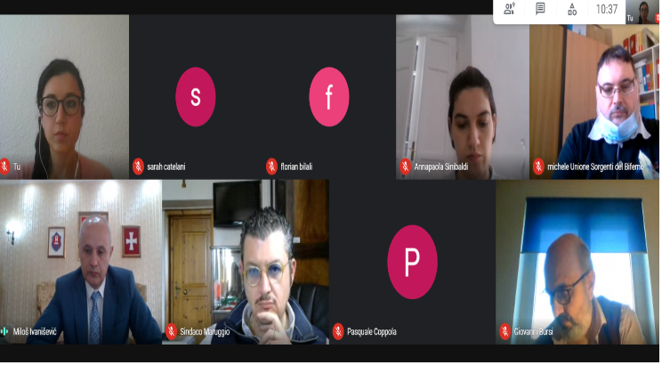  - Mr.FLORIAN BILALI (President Cedir).  They discussed Open Tourism proposes a new vision of the tourist, who sees him more and more as a temporary citizen of our communities, looking for experiences to live and relationships to build.  Open Tourism proposes a new vision of the information and reception system for tourists, where all the economic, commercial and cultural operators of the area can become information points according to the logic of widespread systems.  Open Tourism offers new communication tools with tourists, increasingly digital and interactive and contained in the Open Tourism Kit, the Open Tourism APP and the Open Tourism Site that the project now makes available to the territories and operators who want to join the Circuit.  The presence in the Open Tourism APP requires the provision of the data and information indicated here.  The main overall objective is to develop and implement a cross-border public-private cooperation strategy to promote and enhance cultural and natural heritage and the sustainable economic and social development of territories involved. Contribution to the Programme specific objective: - An integrated territorial marketing strategy will boost the attractiveness of natural and cultural assets. Innovative products will be realised to enhance excellences, provide information and deliver a more structured tourist offer, stimulating more visitors. The Contest for tourists will encourage them (as “temporary citizens”) to take an active role in promoting the appeal of these destinations. The Open Tourism Circuit service will be implemented: tourist and economic operators will increase their competences and be engage to welcome and support tourists. - Smart and sustainable economic and social development will be stimulated by the involvement of local communities as “testimonial” of their territories.  Operators will be empowered and encouraged to create fruitful and friendly relations with visitors, favoring a tourism increase which, in turn, will have positive effects on all business activities. The main output is the Open Tourism Service, a widespread tourist information and welcome service which is constituted by a new cross-border governance model, a set of shared innovative products (Platform, APP, itineraries, brand, etc.) and a Circuit of informal information and welcome points constituted by economic operators in partner territories. Expected results are the improved quality of tourism information and welcome service in the cooperation area and created premises to increase and diversify tourist flows in these territories.

website | phone number | email

