INTERREG IPA II CROSS-BORDER COOPERATION PROGRAMME GREECE -ALBANIA 2014-2020

FIRE PREP Project

Kick off Meeting
21.12.2020

Meeting Minutes
The kick off meeting of FIRE PREP Project, was organized in google meeting online platform in accordance with the Covid-19 situation and regulations of each partner country. All the participants were previously invited to vote in doodle online appointment scheduler about the date and the time that they were available to join in the Kick off meeting. The majority of the Fire Prep project partners agreed about the date 21.12.2020 and the Albanian local time 10:00 AM. All the participants were invited to join the google meet link https://meet.google.com/jca-xhnv-rwq.
This was the agenda scheduled about the organization of the Kick off meeting:
AGENDA
Welcoming Speech of Mayor Berat Municipality, Mr. Ervin Demo
Welcoming Speech of JS’s Officer
Welcoming Speech and short presentation of Project Partners (5 minutes each partner)
Overview of the project by the project manager Mrs. Etleva Dhima
Presentation of Administrative and Financial aspects by the Expert, Mr. Florian Bilali
Presentation of project Working Packages for all partners
Discussion of Financial issues
Final conclusions and end of the meeting

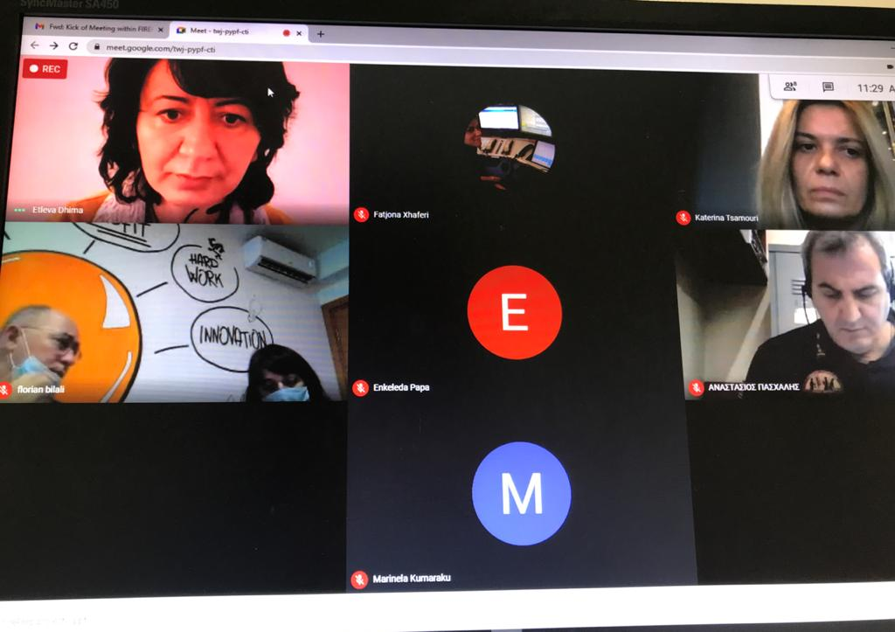

The meeting started with a brief presentation of each participant done by Mrs.Etleva Dhima, project manager of the FirePrep project for the municipality of Berat. The meeting started on time and the participants were partners from Albania: the Lead Partner Mayor of Berat Mr. Ervin Demo, Mrs.Fatjona Xhaferri,PP3, Expert from the Ministry of Defense,PP4 Mrs.Valbona Gogu-from the Ministry of the Tourism and Environment, Mrs.Etleva Dhima-Municipality of Berat, Mr. Florian Bilali-External Expert-CEDIR.
Partners from Greece ,Mrs. Katerina Tsamouri, JTS officer and Mr. Anastasios from Hellenic CORPS,PP2.

- Welcoming all the project partners

- Welcoming Speech by the Mayor of Berat Mr. Ervin Demo about the project implementation.

- Mrs. Katerina Tsamouri, JTS officer:
Mrs. Katerina Tsamouri on her word emphasized the goals of implementing services of FIREPREP, stressing that there is no time to lose and the partners should proceed with the activities. Mrs. Tsamouri also mentioned that partners should open their account in the second level banks so they can precede with their activities. She mentioned also that the Project cannot be expanded more than in 2023.
- Mr. Anastasios from Hellenic CORPS-Project Partner 2
Project Partner 2 from the Hellenic CORPS mentioned that they will try to be on schedule for the procedures to supply with fire trucks the borders of the two countries. Project Partner 2 emphasis that their main aim is to:
- Give and share knowledge about the firefighting
- Protect the environment
- Meet any procedure on time of the fire truck programmed

Mrs. Fatjona Xhaferri -Expert-from the Ministry of Defense -Project Partner 3
Mrs.Fatjona explained that the FIREPREP project will help to increase staff skills and will also open the doors for other projects. She mentioned that the project will help develop collaboration and to help the fire projects. She mentioned that the project will be implemented by the staff of the Civil Protection Agency.
Mrs.Valbona Gogu-from the Ministry of the Tourism and Environment Project Partner 4
In her presentation Mrs.Valbona explained the progress so far of the project startup and the request for the bank account in the Bank OF Albania is in process.
She explained about the design and Promotional Materials and Institutional Capacity analysis and data collection and the fact that PB4 has already approved the annual budget 2021 the co -funding contribution for the Project and the respective funds for the pre-financing of the activities.

- Mrs.Etleva Dhima-Municipality of Berat
Mrs.Etleva Dhima, the representative of the Municipality of Berat explained some main points about the project implementation actions by their part.
- Presentation of the Municipality of the Berat
- Results or the project for the Municipality of Berat
- Ongoing of the project

- Mr. Florian Bilali-External Expert-CEDIR

Mr. Bilali made a project overview by introducing each partner, the project main objectives and goals. In his speech he explained in details all the project Work Packages the Project goals. In made a specifical explanation of all the project management and how all the partners need to collaborate in order to make the project implementation as successful as possible. Some of the main points he mentioned are:
- Main Objectives of the project
- Expected Results
- Project description
- Project Funding
- Work Packages

Meeting Conclusions:
Fire Prep Kick of meeting of the 21st of December 2020 was closed with some main conclusions about the project ongoing and upcoming activities about the project implementation.
- Firstly, that the Albanian Partners PP3 and PP4 should proceed further by opening their account in the second level banks and should send to the LP the Financial Identification Form with the bank details of their account in Bank of Albania ,with the request of prefinancing in order to be able to continue with their activities.
- Secondly, the steering committee decided that each partner should establish their representatives in terms of financial, managerial and communication aspects. Each partner of the Fire Prep project should send their names according the 1. Project Manager,2. Financial Manager 3. Communication Manager to the Lead Partner
- In accordance with the JS Officer, it was requested to the PP4 to continue with the procurement plan in order to initiate with communication.
- Each partner should fill in the template of procurement monitoring template sent to them by the LP and the LP should inform periodically the JTS.
- Each partner should step forward the procurement procedures for the Project’s activities according to the Procurement Plan and should avoid any delays in expenditures’ forecast.
Finally, during the meeting was decided that each partner should send the filled expenditure forecast for 2021 requested from JS.

